Morris Results
1. Morris Results 1 – Distribution by table
Distribution | All Zero | Non Zero | High importance & High interaction | High importance & Low interaction | Low importance & High interaction | Low importance & Low interaction
SURLAG | 1 | 0 | 0 | 0 | 0 | 0
SPCON | 1 | 0 | 0 | 0 | 0 | 0
SPEXP | 1 | 0 | 0 | 0 | 0 | 0
ESCO | 10 | 13 | 44 | 54 | 0 | 32
EPCO | 10 | 13 | 0 | 4 | 0 | 126
GW_REVAP | 12 | 13 | 26 | 0 | 26 | 47
REVAPMN | 19 | 10 | 0 | 0 | 0 | 16
GW_DELAY | 11 | 3 | 22 | 5 | 5 | 78
ALPHA_BF | 12 | 11 | 0 | 0 | 0 | 90
GWAQMN | 11 | 10 | 31 | 0 | 20 | 59
RCHRG_DP | 11 | 11 | 62 | 7 | 1 | 40
OV_N | 6 | 0 | 0 | 0 | 0 | 0
LAT_SED | 2 | 0 | 0 | 0 | 0 | 0
SLSOIL | 4 | 13 | 0 | 0 | 0 | 130
CN2 | 8 | 13 | 65 | 2 | 20 | 43
USLE_P | 1 | 1 | 0 | 0 | 0 | 10
CHW2 | 2 | 0 | 0 | 0 | 0 | 0
CHD | 2 | 0 | 0 | 0 | 0 | 0
CH_L2 | 3 | 0 | 0 | 0 | 0 | 0

2. Morris Results 2 – Distribution by graph (Average)
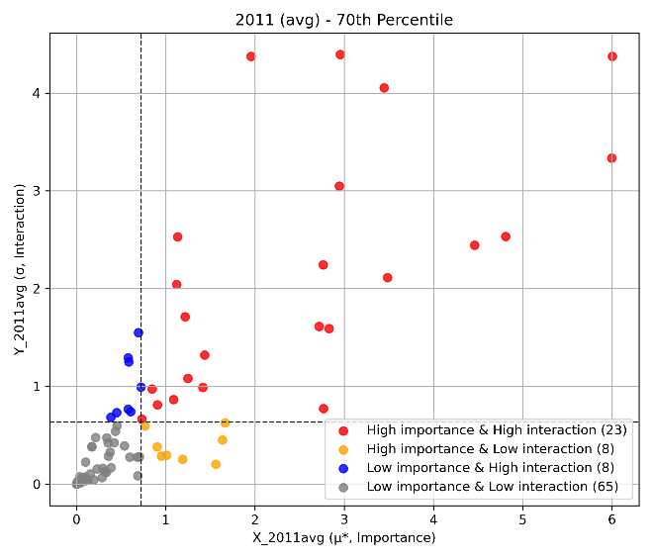 | 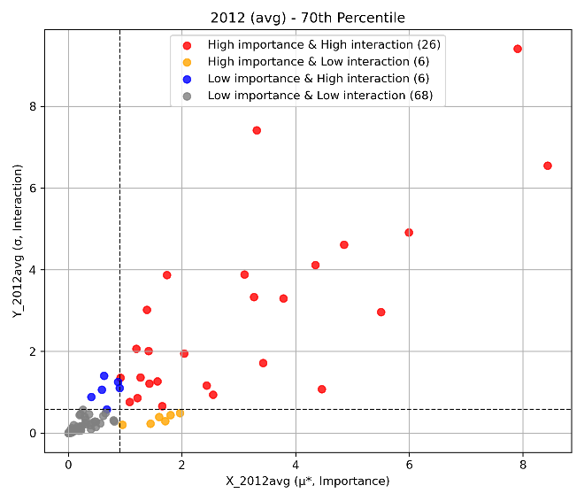
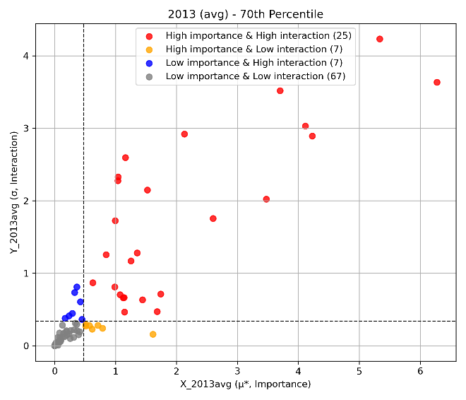 | 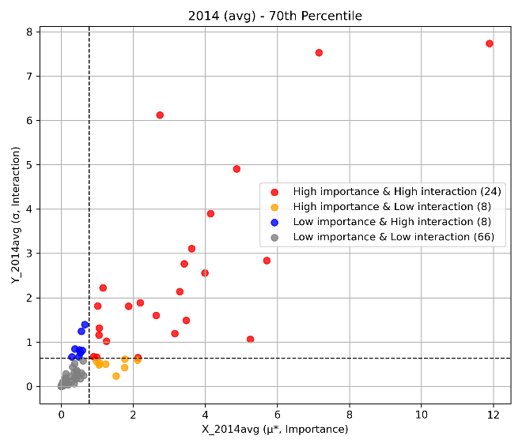
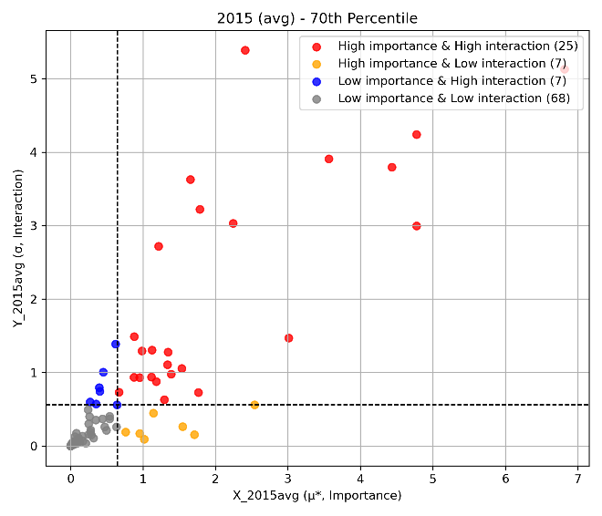 | 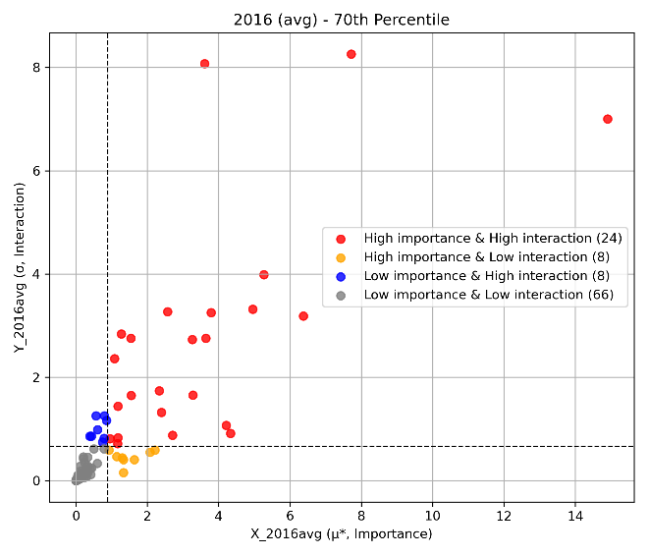
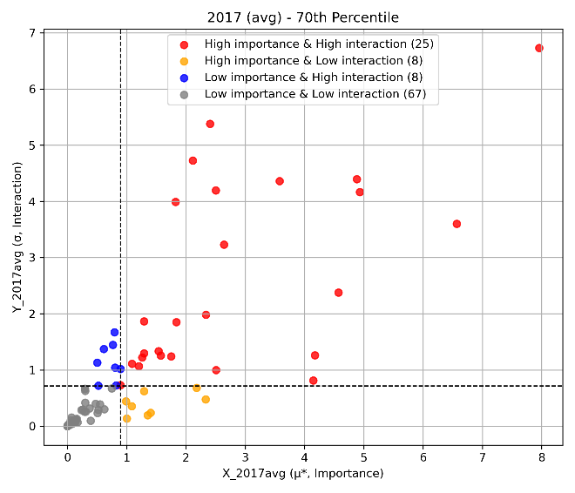 | 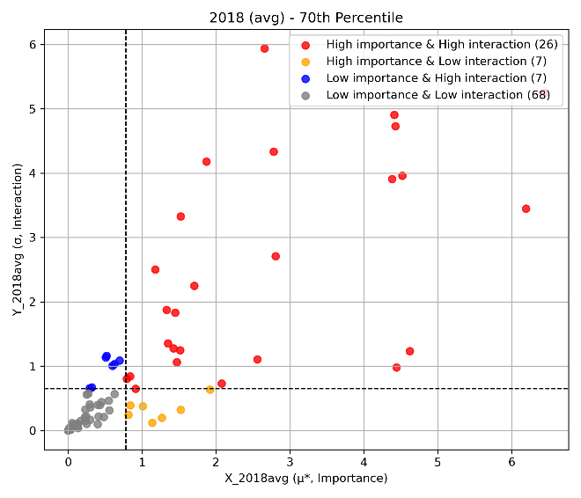
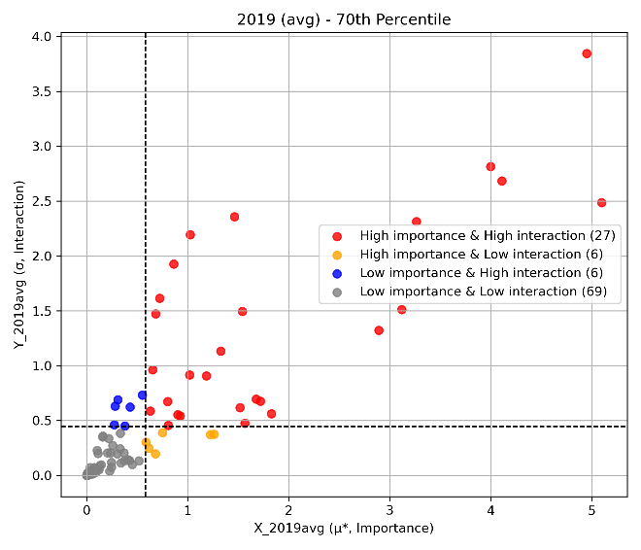 | 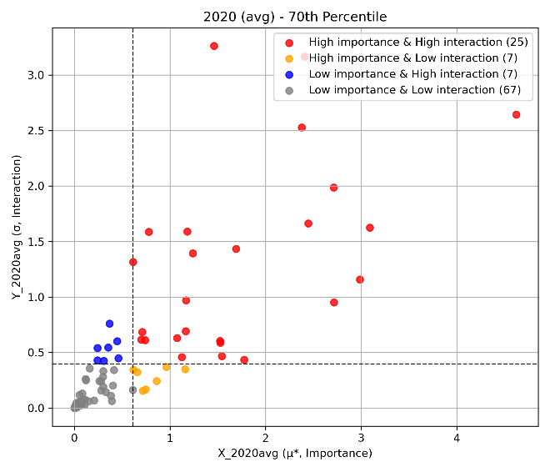

3. Morris Results 3 – Distribution by graph (Maximum)
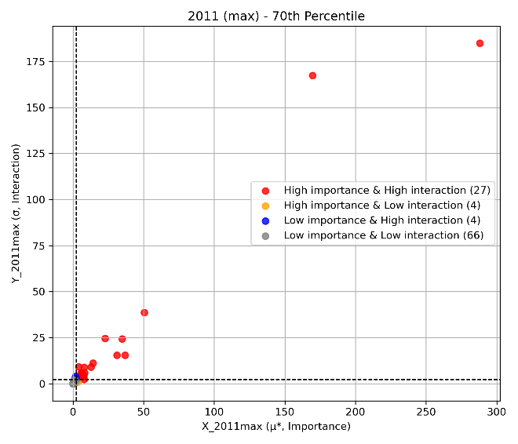 | 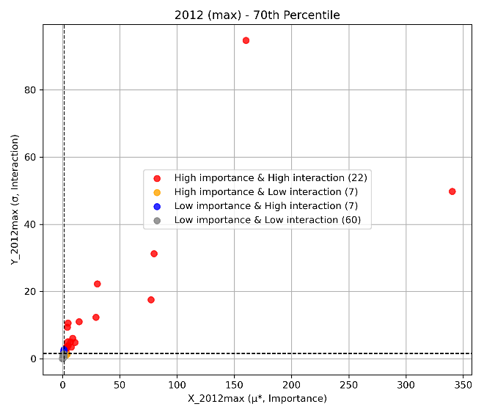
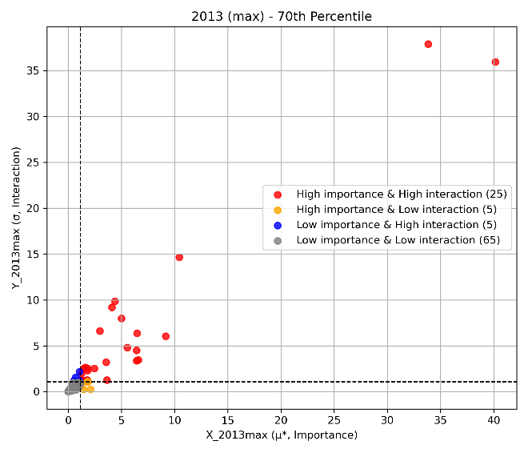 | 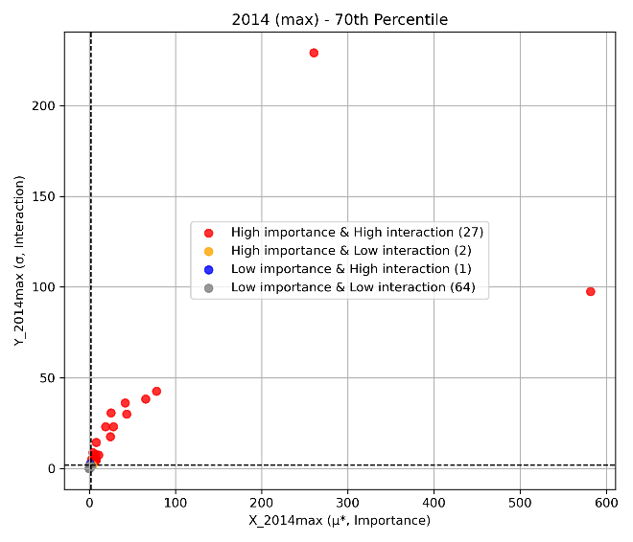
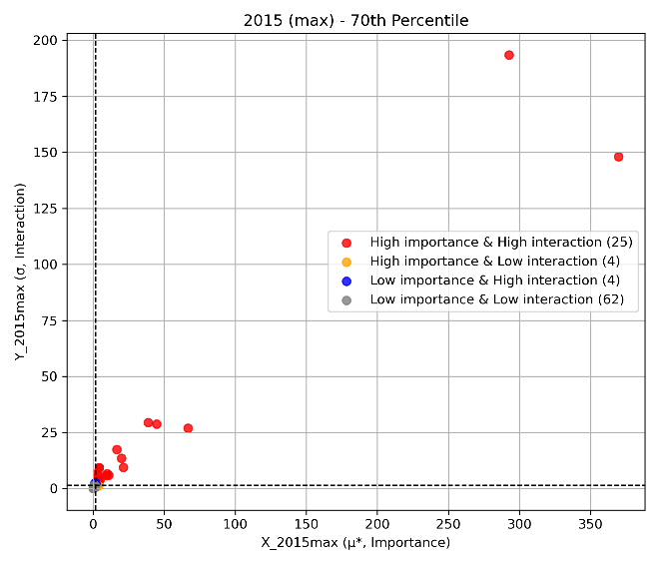 | 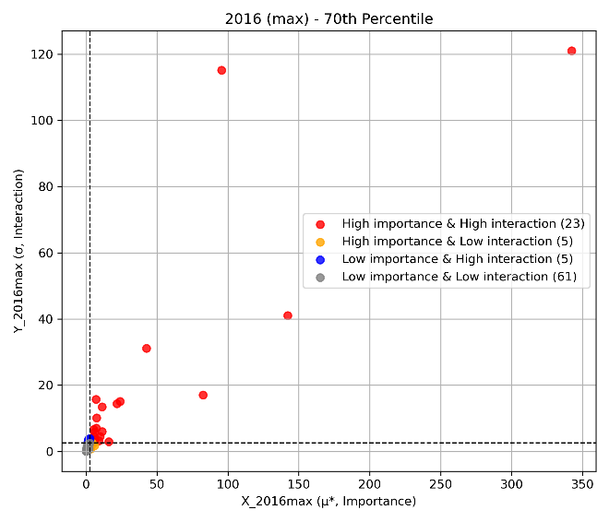
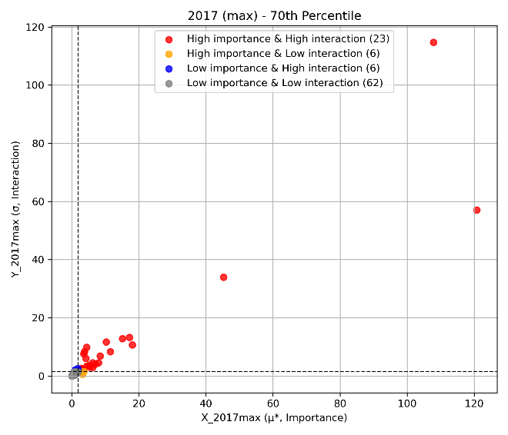 | 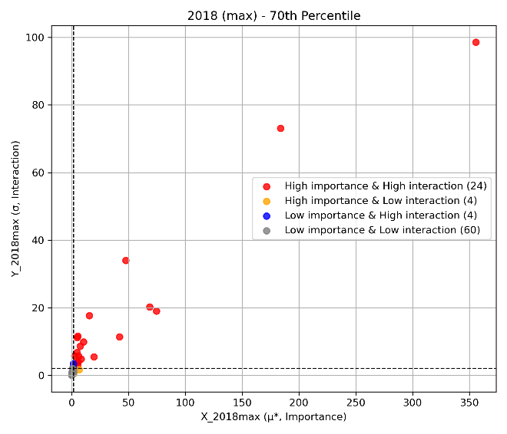
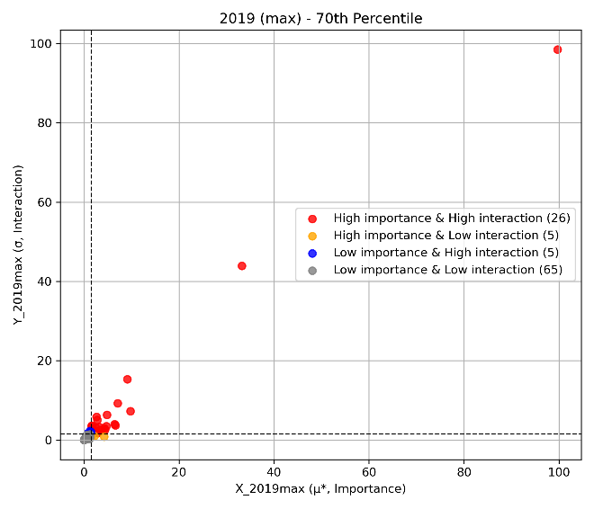 | 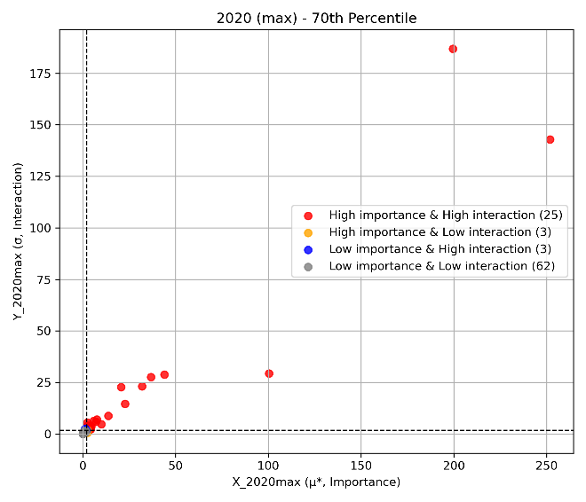

4. Morris Results 4 – Distribution by graph (Minimum)
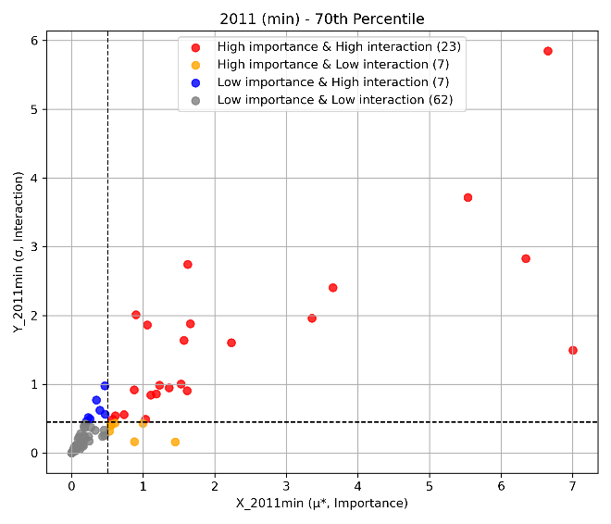 | 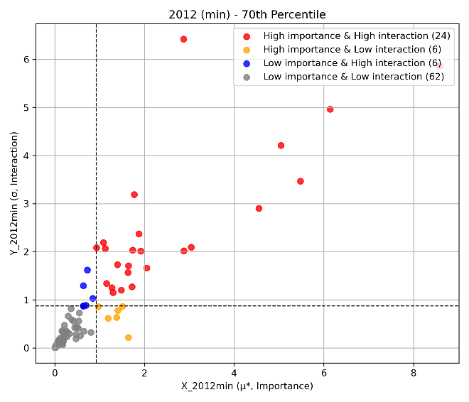
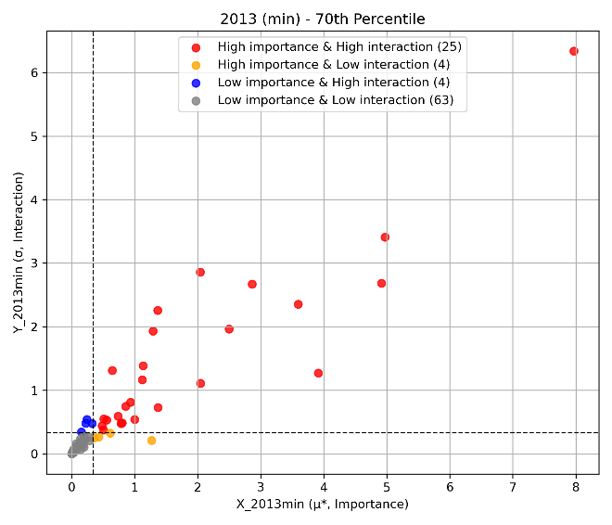 | 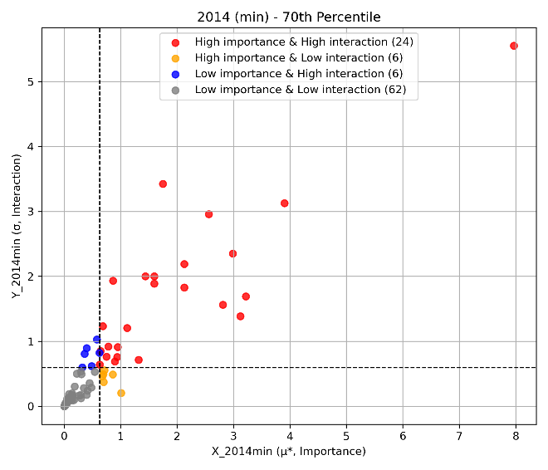
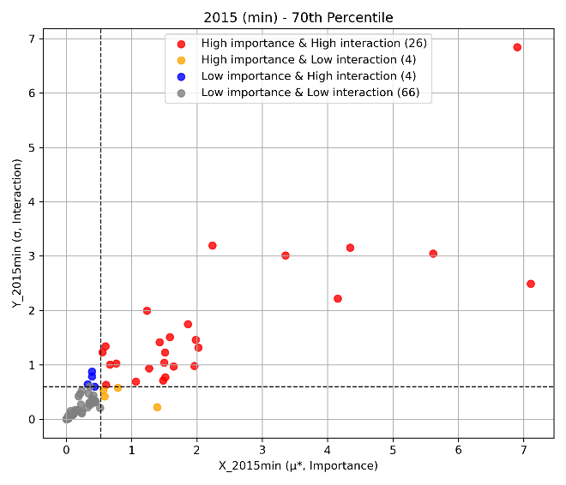 | 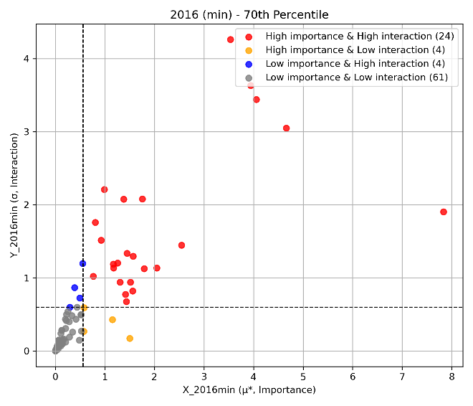
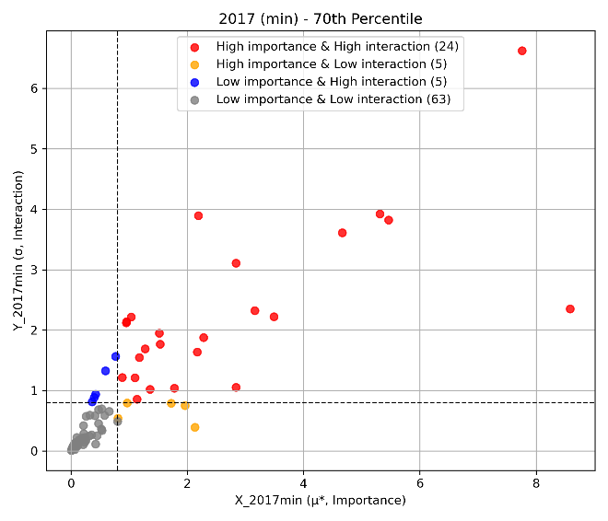 | 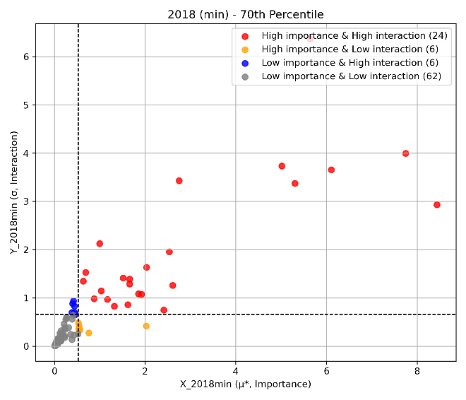
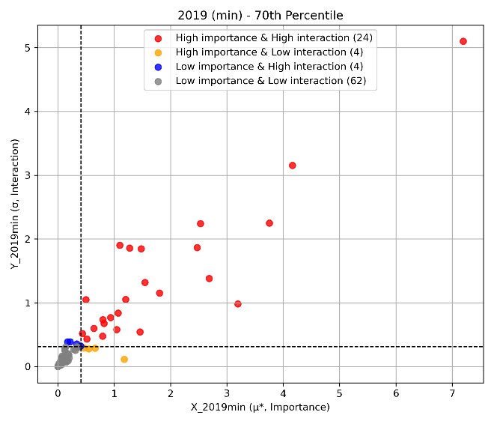 | 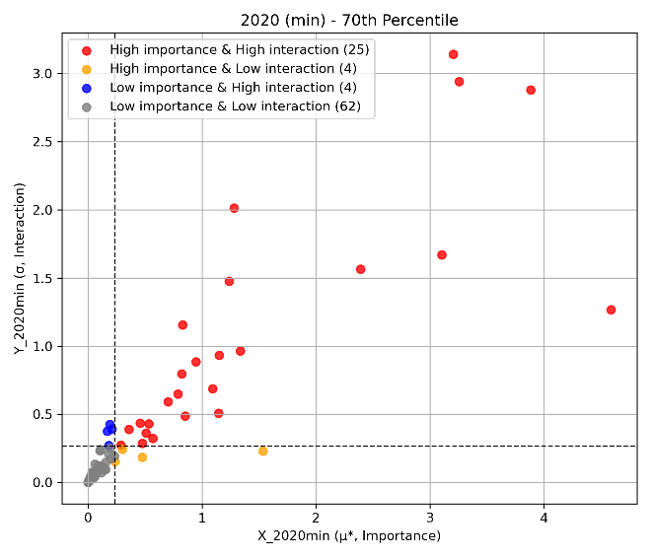

Observed
- All Zero Similarity:
- Non Zero Similarity:
- High importance vs Low importance (Subbasin diff):

Sobol Results
Subbasin combination : ‘Combination number : Subbasin number’
Combination 1: 1,2,5
Combination 2: 3,4,8,9,13,14,15
Combination 3: 6,7,10,11,12
Combination 4: 16,17,20,21,22
Combination 5: 18,19,23,24,25,26,27,28,29,30,32,33,37
Combination 6: 34,35,36
Combination 7: 38,39,40,41,48,49,50,51,52
Combination 8: 44,45,55,57,58,59,60,61,62,63,64,67,68,69,71,74,78,79,80
Combination 9: 72,73,86
Combination 10: 81,82,89,90,91,92,93,94,97,98,99,100,103,107,108,109,113,114,116
Combination 11: 83
Combination 12: 110

Map of each combination:
- Subbasin MUKRW(Middle and Upper KRW)
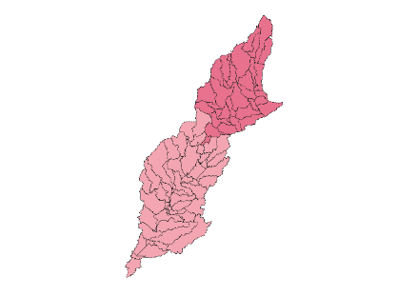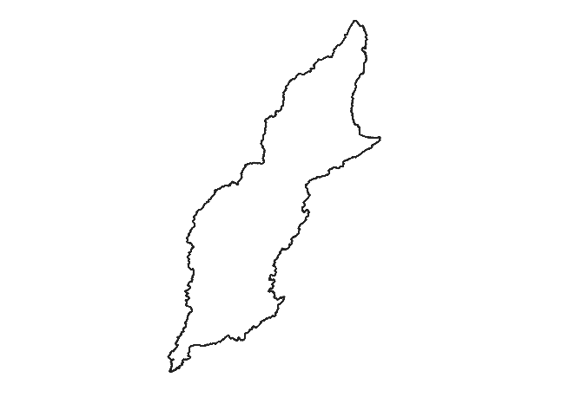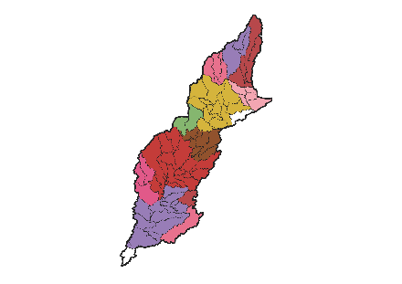
Character 1: Subbasin Area size
1 | 38885.9 | 5.6%
2 | 54235.3 | 7.8%
3 | 30232.1 | 4.4%
4 | 28649.8 | 4.1%
5 | 111836 | 16.1%
6 | 25314 | 3.7%
7 | 46259.1 | 6.7%
8 | 156536 | 22.6%
9 | 39513.7 | 5.7%
10 | 122243 | 17.6%
11 | 11189.3 | 1.6%
12 | 28402.7 | 4.1%

Character 2: Subbasin Landuse (Pixel)
2011 | 1 | 2 | 3 | 4 | 5 | 6 | 7
1 | 93.3% | 0.0% | 5.6% | 0.3% | 0.8% | 0.0% | 0.0%
2 | 82.7% | 0.4% | 13.2% | 1.6% | 1.9% | 0.1% | 0.2%
3 | 92.6% | 0.1% | 5.7% | 0.8% | 0.7% | 0.0% | 0.0%
4 | 86.8% | 0.3% | 7.9% | 2.8% | 1.9% | 0.1% | 0.2%
5 | 75.8% | 4.5% | 6.5% | 10.9% | 2.2% | 0.0% | 0.1%
6 | 85.4% | 0.2% | 5.5% | 7.3% | 1.6% | 0.0% | 0.0%
7 | 68.1% | 0.5% | 7.2% | 21.8% | 2.2% | 0.1% | 0.1%
8 | 61.6% | 0.8% | 8.2% | 26.9% | 2.4% | 0.0% | 0.0%
9 | 67.9% | 0.5% | 7.1% | 21.3% | 3.1% | 0.0% | 0.0%
10 | 59.5% | 9.3% | 6.8% | 19.9% | 3.5% | 0.0% | 0.9%
11 | 58.6% | 0.3% | 6.8% | 31.7% | 2.6% | 0.0% | 0.0%
12 | 56.5% | 0.5% | 8.9% | 28.9% | 5.2% | 0.0% | 0.0%
2016 | 1 | 2 | 3 | 4 | 5 | 6 | 7
1 | 93.0% | 0.0% | 5.4% | 0.3% | 1.3% | 0.0% | 0.0%
2 | 81.0% | 0.2% | 13.2% | 1.7% | 3.7% | 0.0% | 0.1%
3 | 92.0% | 0.0% | 5.5% | 0.8% | 1.7% | 0.0% | 0.0%
4 | 82.9% | 0.1% | 7.9% | 2.9% | 5.8% | 0.0% | 0.3%
5 | 73.4% | 4.3% | 6.3% | 11.1% | 5.0% | 0.0% | 0.0%
6 | 81.2% | 0.1% | 4.9% | 7.3% | 6.5% | 0.0% | 0.0%
7 | 62.0% | 0.3% | 7.1% | 21.9% | 8.6% | 0.1% | 0.0%
8 | 53.9% | 0.6% | 7.9% | 26.8% | 10.7% | 0.0% | 0.0%
9 | 59.9% | 0.3% | 6.8% | 21.2% | 11.9% | 0.0% | 0.0%
10 | 54.7% | 9.0% | 6.6% | 19.7% | 9.0% | 0.0% | 0.9%
11 | 52.9% | 0.2% | 6.4% | 31.9% | 8.7% | 0.0% | 0.0%
12 | 50.9% | 0.5% | 8.5% | 29.0% | 11.0% | 0.0% | 0.0%
Diff | 1 | 2 | 3 | 4 | 5 | 6 | 7
1 | -0.30% | 0.00% | -0.20% | 0.00% | 0.50% | 0.00% | 0.00%
2 | -1.70% | -0.20% | 0.00% | 0.10% | 1.80% | -0.10% | -0.10%
3 | -0.60% | -0.10% | -0.20% | 0.00% | 1.00% | 0.00% | 0.00%
4 | -3.90% | -0.20% | 0.00% | 0.10% | 3.90% | -0.10% | 0.10%
5 | -2.40% | -0.20% | -0.20% | 0.20% | 2.80% | 0.00% | -0.10%
6 | -4.20% | -0.10% | -0.60% | 0.00% | 4.90% | 0.00% | 0.00%
7 | -6.10% | -0.20% | -0.10% | 0.10% | 6.40% | 0.00% | -0.10%
8 | -7.70% | -0.20% | -0.30% | -0.10% | 8.30% | 0.00% | 0.00%
9 | -8.00% | -0.20% | -0.30% | -0.10% | 8.80% | 0.00% | 0.00%
10 | -4.80% | -0.30% | -0.20% | -0.20% | 5.50% | 0.00% | 0.00%
11 | -5.70% | -0.10% | -0.40% | 0.20% | 6.10% | 0.00% | 0.00%
12 | -5.60% | 0.00% | -0.40% | 0.10% | 5.80% | 0.00% | 0.00%

Character 3: Subbasin Canopy
2011 | 0-9 | 10-19 | 20-29 | 30-39 | 40-49 | 50-59 | 60-69 | 70-79 | 80-89 | 90-99
1 | 0.0% | 15.7% | 37.1% | 9.7% | 3.7% | 4.9% | 3.7% | 9.7% | 15.4% | 0.0%
2 | 0.2% | 29.1% | 27.4% | 8.3% | 4.3% | 3.8% | 3.0% | 5.0% | 16.9% | 2.0%
3 | 0.0% | 7.7% | 18.6% | 13.0% | 10.9% | 8.9% | 8.4% | 15.2% | 16.1% | 1.1%
4 | 0.0% | 12.0% | 11.8% | 7.4% | 5.3% | 6.0% | 5.8% | 10.2% | 39.1% | 2.4%
5 | 0.0% | 4.5% | 7.9% | 9.2% | 7.5% | 7.6% | 7.7% | 9.6% | 28.0% | 18.1%
6 | 0.0% | 1.9% | 7.5% | 10.6% | 12.7% | 10.5% | 11.0% | 13.4% | 28.0% | 4.4%
7 | 0.1% | 2.8% | 5.6% | 7.5% | 8.3% | 10.1% | 10.6% | 12.9% | 26.7% | 15.5%
8 | 0.0% | 2.2% | 6.4% | 8.7% | 8.1% | 9.0% | 9.2% | 10.4% | 28.2% | 17.9%
9 | 0.0% | 1.3% | 6.3% | 8.8% | 8.8% | 10.1% | 10.7% | 11.6% | 23.4% | 19.1%
10 | 0.0% | 0.7% | 5.9% | 10.4% | 8.9% | 8.2% | 7.8% | 6.6% | 20.8% | 30.8%
11 | 0.0% | 0.7% | 5.3% | 7.4% | 6.5% | 7.2% | 8.1% | 9.7% | 44.0% | 11.0%
12 | 0.0% | 1.8% | 5.3% | 8.0% | 6.2% | 6.5% | 6.1% | 6.5% | 20.2% | 39.3%
2016 | 0-9 | 10-19 | 20-29 | 30-39 | 40-49 | 50-59 | 60-69 | 70-79 | 80-89 | 90-99
1 | 0.0% | 17.1% | 34.8% | 5.9% | 4.2% | 5.2% | 4.9% | 11.1% | 16.4% | 0.3%
2 | 0.2% | 28.7% | 27.7% | 7.5% | 3.6% | 2.9% | 3.1% | 6.7% | 18.3% | 1.2%
3 | 0.0% | 9.8% | 19.6% | 8.3% | 9.1% | 8.1% | 8.9% | 16.6% | 18.9% | 0.6%
4 | 0.0% | 10.6% | 11.9% | 6.1% | 5.3% | 5.8% | 5.6% | 11.3% | 41.9% | 1.5%
5 | 0.0% | 5.6% | 7.9% | 7.4% | 5.5% | 6.3% | 7.1% | 12.1% | 32.6% | 15.6%
6 | 0.0% | 5.5% | 9.1% | 8.2% | 8.3% | 7.2% | 10.2% | 18.1% | 31.0% | 2.4%
7 | 0.0% | 3.4% | 6.3% | 5.6% | 5.3% | 5.9% | 7.8% | 13.2% | 37.0% | 15.5%
8 | 0.0% | 3.4% | 7.0% | 6.9% | 5.9% | 6.7% | 7.4% | 11.9% | 36.1% | 14.6%
9 | 0.0% | 2.6% | 6.6% | 7.1% | 6.3% | 7.8% | 8.1% | 13.6% | 32.6% | 15.2%
10 | 0.0% | 2.0% | 6.9% | 8.1% | 6.7% | 6.8% | 7.5% | 9.5% | 27.8% | 24.8%
11 | 0.0% | 1.9% | 5.4% | 5.9% | 5.8% | 6.0% | 7.9% | 12.3% | 46.1% | 8.8%
12 | 0.0% | 2.7% | 6.3% | 6.0% | 4.8% | 5.3% | 6.1% | 8.8% | 30.9% | 29.1%
Diff | 0-9 | 10-19 | 20-29 | 30-39 | 40-49 | 50-59 | 60-69 | 70-79 | 80-89 | 90-99
1 | 0.0% | 1.4% | -2.3% | -3.8% | 0.5% | 0.3% | 1.2% | 1.4% | 1.0% | 0.3%
2 | 0.0% | -0.4% | 0.3% | -0.8% | -0.7% | -0.9% | 0.1% | 1.7% | 1.4% | -0.8%
3 | 0.0% | 2.1% | 1.0% | -4.7% | -1.8% | -0.8% | 0.5% | 1.4% | 2.8% | -0.5%
4 | 0.0% | -1.4% | 0.1% | -1.3% | 0.0% | -0.2% | -0.2% | 1.1% | 2.8% | -0.9%
5 | 0.0% | 1.1% | 0.0% | -1.8% | -2.0% | -1.3% | -0.6% | 2.5% | 4.6% | -2.5%
6 | 0.0% | 3.6% | 1.6% | -2.4% | -4.4% | -3.3% | -0.8% | 4.7% | 3.0% | -2.0%
7 | -0.1% | 0.6% | 0.7% | -1.9% | -3.0% | -4.2% | -2.8% | 0.3% | 10.3% | 0.0%
8 | 0.0% | 1.2% | 0.6% | -1.8% | -2.2% | -2.3% | -1.8% | 1.5% | 7.9% | -3.3%
9 | 0.0% | 1.3% | 0.3% | -1.7% | -2.5% | -2.3% | -2.6% | 2.0% | 9.2% | -3.9%
10 | 0.0% | 1.3% | 1.0% | -2.3% | -2.2% | -1.4% | -0.3% | 2.9% | 7.0% | -6.0%
11 | 0.0% | 1.2% | 0.1% | -1.5% | -0.7% | -1.2% | -0.2% | 2.6% | 2.1% | -2.2%
12 | 0.0% | 0.9% | 1.0% | -2.0% | -1.4% | -1.2% | 0.0% | 2.3% | 10.7% | -10.2%

Character 4: Subbasin Inputs (DEM,Slop,Soil)
1. DEM
2. SLOPE
3. Soil – Hydrologic Soil Group
A: low runoff (high infiltration), D: high runoff (low infiltration)
4. Soil - Texture (Clay, Sil, Sand)

 | DEM | Slope | HSG | Clay | Silt | Sand
1 | 208.27 | 0.42 | B | 23.84 | 56.01 | 20.15
2 | 210.10 | 0.57 | B | 24.80 | 59.65 | 15.55
3 | 210.72 | 0.46 | B | 23.25 | 58.68 | 18.08
4 | 202.14 | 0.54 | B | 22.68 | 58.43 | 18.89
5 | 202.83 | 1.01 | B | 23.23 | 57.57 | 19.20
6 | 198.84 | 1.06 | B | 22.95 | 61.95 | 15.10
7 | 186.31 | 1.59 | B | 23.47 | 57.36 | 19.17
8 | 183.71 | 1.77 | C | 21.69 | 56.09 | 22.22
9 | 179.72 | 1.56 | D | 19.12 | 59.99 | 20.89
10 | 154.42 | 0.98 | C | 21.63 | 54.57 | 23.81
11 | 179.95 | 1.55 | D | 22.50 | 53.96 | 23.54
12 | 172.73 | 1.28 | C | 22.04 | 53.58 | 24.38

Sobol Results 1 – First and total-first order index result (Avg)

First-order | RCHRG_DP | ESCO | CN2 | GW_REVAP | GW_DELAY | EPCO | GWQMN
1 | 0.00 | 0.01 | 0.00
2 |  | 0.02 | 0.02
3 |  | 0.01 | 0.02
4 |  | 0.01 | 0.31
5 | 0.04 | 0.02 | 0.38 | 0.00 | 0.00 | 0.01
6 | 0.00 | 0.01 | 0.32
7 | -0.01 | 0.01 | 0.33 | 0.00 | 0.00 | 0.01
8 | 0.04 | 0.05 | 0.36 | 0.01 | 0.01 | 0.01 | 0.02
9 | 0.01 | 0.01 | 0.33 | 0.00 | 0.00 |  | 0.00
10 | 0.03 | 0.02 | 0.39 | 0.02 | 0.01 | 0.01 | 0.01
11 | 0.00 | 0.01 | 0.32 |  | 0.00 |  | 0.00
12 | 0.00 | 0.00 | 0.32 |  | 0.00 | 0.01 | 0.00
Total-First order | RCHRG_DP | ESCO | CN2 | GW_REVAP | GW_DELAY | EPCO | GWQMN
1 | 0.00 | 0.00 | 0.00
2 |  | 0.00 | 0.00
3 |  | 0.00 | 0.00
4 |  | 0.00 | 0.00
5 | 0.02 | 0.00 | 0.00 | 0.01 | 0.00 | 0.00
6 | 0.00 | 0.00 | 0.00
7 | 0.00 | 0.00 | 0.00 | 0.00 | 0.00 | 0.00
8 | 0.08 | 0.01 | 0.00 | 0.01 | 0.00 | 0.00 | 0.02
9 | 0.00 | 0.00 | 0.00 | 0.00 | 0.00 |  | 0.00
10 | 0.00 | 0.00 | 0.00 | 0.00 | 0.00 | 0.00 | 0.00
11 | 0.00 | 0.00 | 0.00 |  | 0.00 |  | 0.00
12 | 0.00 | 0.00 | 0.00 |  | 0.00 | 0.00 | 0.00

Observed:
- CN2 value is high quantity : (1,2,3 vs 4-12 subbasin)
- Almost does not have interaction

Sobol Result 2 – Maximum

First-order | RCHRG_DP | ESCO | CN2 | GW_REVAP | GW_DELAY | EPCO | GWQMN
1 | 0.00 | 0.00 | 0.00
2 |  | 0.00 | 0.00
3 |  | 0.00 | 0.00
4 |  | 0.00 | 0.27
5 | 0.00 | 0.00 | 0.27 | 0.00 | 0.00 | 0.00
6 | 0.00 | 0.00 | 0.27 | 0.00
7 | 0.00 | 0.00 | 0.28 | 0.00 | 0.00 | 0.00
8 | 0.00 | 0.01 | 0.36 | 0.00 | 0.00 | 0.00 | 0.00
9 | 0.00 | 0.00 | 0.28 | 0.00 | 0.00 |  | 0.00
10 | 0.00 | 0.00 | 0.42 | 0.00 | 0.00 | 0.00 | 0.00
11 | 0.00 | 0.00 | 0.27 |  | 0.00 |  | 0.00
12 | 0.00 | 0.00 | 0.28 |  | 0.00 | 0.00 | 0.00
Total-First order | RCHRG_DP | ESCO | CN2 | GW_REVAP | GW_DELAY | EPCO | GWQMN
1 | 0.00 | 0.00 | 0.00
2 |  | 0.00 | 0.00
3 |  | 0.00 | 0.00
4 |  | 0.00 | 0.00
5 | 0.00 | 0.00 | 0.00 | 0.00 | 0.00 | 0.00
6 | 0.00 | 0.00 | 0.00 | 0.00
7 | 0.00 | 0.00 | 0.00 | 0.00 | 0.00 | 0.00
8 | 0.00 | 0.00 | 0.00 | 0.00 | 0.00 | 0.00 | 0.00
9 | 0.00 | 0.00 | 0.00 | 0.00 | 0.00 |  | 0.00
10 | 0.00 | 0.00 | 0.00 | 0.00 | 0.00 | 0.00 | 0.00
11 | 0.00 | 0.00 | 0.00 |  | 0.00 |  | 0.00
12 | 0.00 | 0.00 | 0.00 |  | 0.00 | 0.00 | 0.00

Observed:
- CN2 value is high quantity : (1,2,3 vs 4-12 subbasin)
- No interaction

Sobol Result 3 – Minimum

First-order | RCHRG_DP | ESCO | CN2 | GW_REVAP | GW_DELAY | EPCO | GWQMN
1 | 0.00 | 0.00 | 0.00
2 |  | 0.00 | 0.04
3 |  | 0.00 | 0.00
4 |  | -0.01 | 0.39
5 | 0.04 | 0.00 | 0.41 | 0.00 | 0.00 | 0.00
6 | 0.01 | 0.00 | 0.38
7 | -0.02 | 0.00 | 0.39 | 0.00 | 0.00 | 0.00
8 | 0.15 | 0.01 | 0.45 | 0.01 | 0.05 | 0.00 | 0.03
9 | 0.01 | 0.00 | 0.39 | 0.00 | 0.00 |  | 0.00
10 | 0.03 | 0.01 | 0.39 | 0.00 | 0.01 | 0.00 | 0.01
11 | 0.00 | 0.00 | 0.38 |  | 0.00 |  | 0.00
12 | -0.01 | -0.01 | 0.39 |  | 0.00 | 0.00 | 0.00
Total-First order | RCHRG_DP | ESCO | CN2 | GW_REVAP | GW_DELAY | EPCO | GWQMN
1 | 0.00 | 0.01 | 0.02
2 |  | 0.01 | 0.00
3 |  | 0.01 | 0.01
4 |  | 0.01 | 0.00
5 | 0.02 | 0.02 | 0.00 | 0.01 | 0.01 | 0.01
6 | 0.00 | 0.01 | 0.00
7 | 0.02 | 0.01 | 0.00 | 0.00 | 0.01 | 0.01
8 | 0.11 | 0.05 | 0.00 | 0.00 | 0.03 | 0.01 | 0.02
9 | 0.00 | 0.01 | 0.00 | 0.00 | 0.00 |  | 0.00
10 | 0.05 | 0.03 | 0.00 | 0.02 | 0.01 | 0.01 | 0.03
11 | 0.00 | 0.01 | 0.00 |  | 0.00 |  | 0.00
12 | 0.02 | 0.01 | 0.00 |  | 0.01 | 0.01 | 0.00

Observed:
- CN2 value is high quantity : (1,2,3 vs 4-12 subbasin)
- It has few interaction

Gumbel Results

Gumbel Results 1 – Observed Gumbel distribution
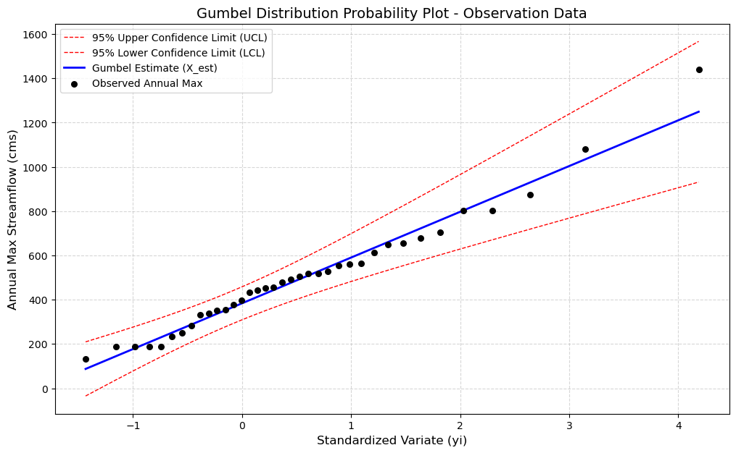

Gumbel Results 2 – Risk analysis
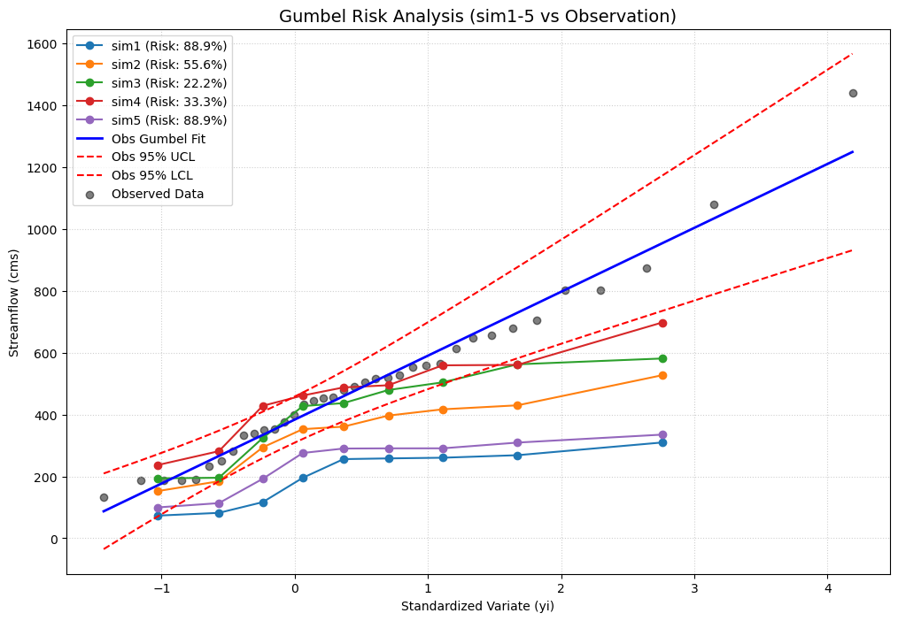

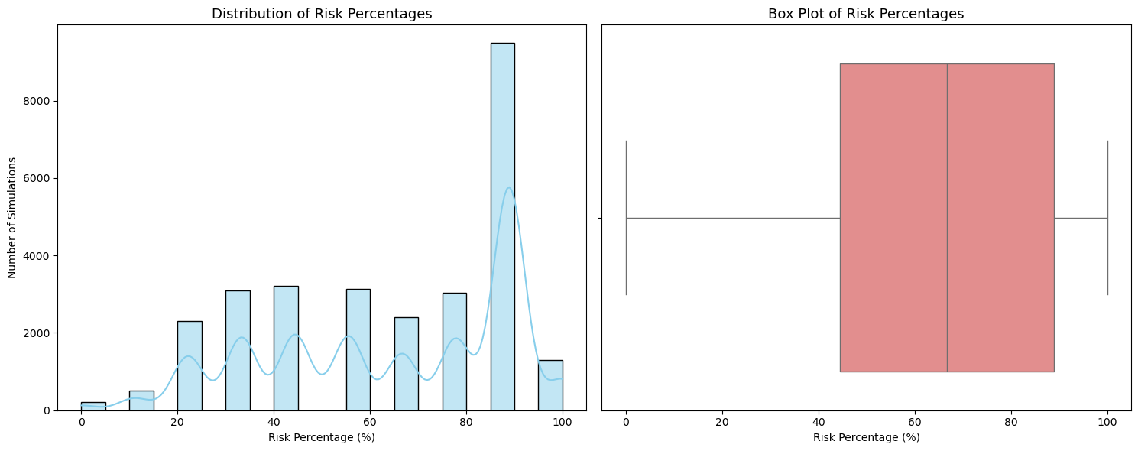

Gumbel Results 3 – Sobol about Risk analysis

First-order | RCHRG_DP | ESCO | CN2 | GW_REVAP | GW_DELAY | EPCO | GWQMN
1 | 0.00 | 0.00 | 0.00
2 |  | -0.01 | 0.00
3 |  | 0.00 | 0.00
4 |  | 0.00 | 0.00
5 | 0.01 | 0.00 | 0.01 | 0.00 | 0.00 | 0.00
6 | 0.00 | 0.00 | 0.04
7 | 0.00 | 0.00 | 0.08 | 0.00 | 0.00 | 0.00
8 | -0.01 | 0.01 | 0.27 | 0.00 | 0.00 | 0.01 | 0.00
9 | 0.00 | 0.01 | 0.02 | 0.00 | 0.00 |  | 0.00
10 | 0.00 | 0.01 | 0.03 | 0.00 | 0.00 | 0.00 | 0.00
11 | 0.00 | 0.00 | 0.00 |  | 0.00 |  | 0.00
12 | 0.00 | 0.00 | -0.01 |  | 0.00 | 0.00 | 0.00
Total-First order | RCHRG_DP | ESCO | CN2 | GW_REVAP | GW_DELAY | EPCO | GWQMN
1 | 0.00 | 0.00 | 0.00
2 |  | 0.00 | 0.00
3 |  | 0.00 | 0.00
4 |  | 0.00 | 0.00
5 | 0.00 | 0.00 | 0.00 | 0.00 | 0.00 | 0.00
6 | 0.00 | 0.00 | 0.03
7 | 0.00 | 0.00 | 0.14 | 0.00 | 0.00 | 0.00
8 | 0.02 | 0.05 | 0.67 | 0.00 | 0.00 | 0.00 | 0.00
9 | 0.00 | 0.00 | 0.12 | 0.00 | 0.00 |  | 0.00
10 | 0.00 | 0.00 | 0.58 | 0.00 | 0.00 | 0.00 | 0.00
11 | 0.00 | 0.00 | 0.05 |  | 0.00 |  | 0.00
12 | 0.00 | 0.00 | 0.05 |  | 0.00 | 0.00 | 0.00

